EXPERIMENT 3
Simulation-Based Analysis of MOS Structure and Gate-Oxide Formation Using NanoHUB

Circuit diagram:
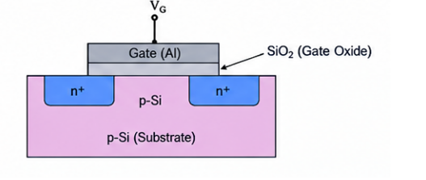

Output Parameter Table:

S.No. | Output Parameter | Theoretical / Expected Value | Practical / Simulated Value | % Deviation
1 | Oxidation process | Proper SiO₂ formation | SiO₂ layer formed | 0% deviation
2 | Gate oxide thickness | 4 nm | 4 nm | 0% deviation
3 | Gate length | 180 nm | 180 nm | 0% deviation
4 | Gate width | 1 µm | 1 µm | 0% deviation
5 | MOS layer structure | Si / SiO₂ / Gate | Si / SiO₂ / Gate | 0% deviation
6 | Oxide uniformity | Uniform layer | Uniform oxide layer observed | 0% deviation
7 | Gate capacitance | 1.55 fF | 1.55 fF | 0% deviation
8 | Interface/oxide quality | Proper MOS interface | Proper MOS interface observed | 0% deviation

Output:

